Chapter 2 p.51

Most targeted sectors by region

Nation-state cyber operations targeted various sectors across the globe. Perceived soft targets—such as think tanks, NGOs, and universities—remained top targets like last year, as threat actors likely view them as easier initial access vectors to gain insights into a country’s policy or science and technology communities. At the same time, targeting of traditionally more hardened targets, such as government agencies and the defense industry, rose as geopolitical tensions rose surrounding the Ukraine War, the Taiwan Straits, and Iran and North Korea’s nuclear programs. Increased sophistication by actors also likely enabled actors to have increased access to harder targets.

Pie chart showing percentages of the most targeted sectors by region in Europe. It shows A. Think tanks/NGOs: 17%, B. Government: 14%, C. Education: 9%, D. IT: 9%, E. Communications: 6%, F. Intergovernmental Organizations : 6%, G. Transportation: 5%, H. Finance: 4%, I. Défense Industry: 3%, J. Energy: 3%, and K. Other: 25%.

Pie chart showing percentages of the most targeted sectors by region in Middle East and North Africa. It shows A. Education: 19%, B. Government: 13%, C. IT: 13%, D. Communications: 7%, E. Transportation: 6%, F. Finance: 6%, G. Energy: 4%, H. Défense Industry: 4%, and I. Other: 28%.

Pie chart showing percentages of the most targeted sectors by region in Asia-Pacific. It shows A. Education: 22%, B. IT: 17%, C. Transportation: 9%, D. Government: 9%, E. Communication: 8%, F. Media: 6%, G. Think tanks/NGOs: 6%, H. Finance: 5%, and I. Other: 18%.

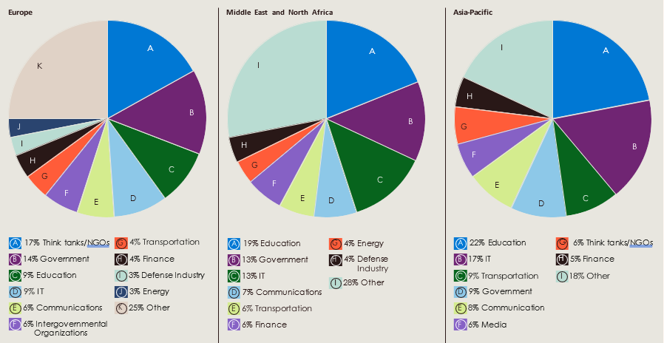

Source: Microsoft Threat Intelligence nation state notifications